

Design I Need

1. Titles
I need an improvement over the current design of the titles.

Guidelines
We need to transform this:
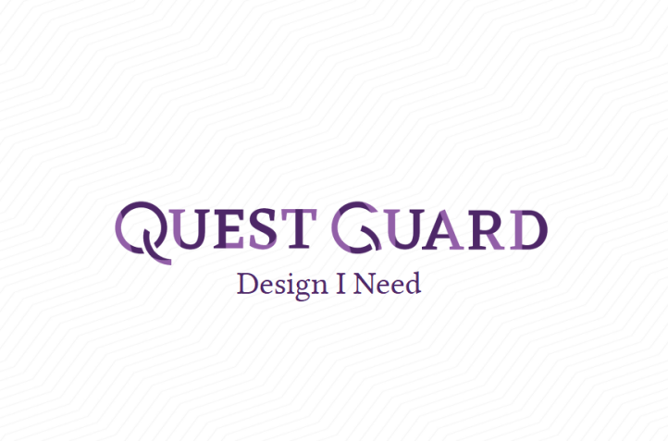

Into something like this:
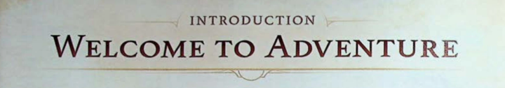

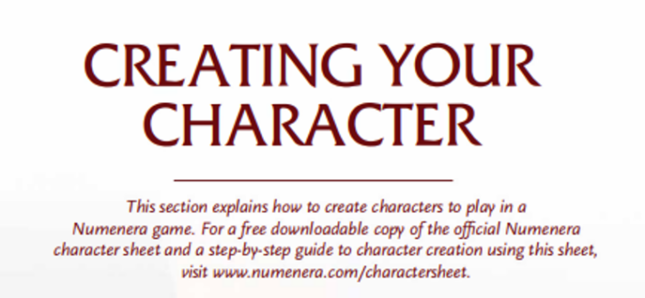
What I Need
- Decoration with line art (like in the Welcome To Adventure image).
- Subtitle (either up or down)

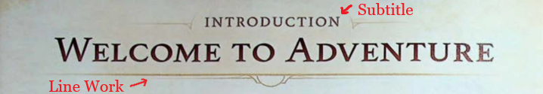

Do Not Change
- The title font will always remain the same. It is a custom font. Use the templates attached in the folder. Please do not change this font.

Style & Specifications
- The font for the subtitle can be any Serif font, but preferably Linux Libertine (attached in the folder). It can be uppercase or not, as long as it looks good.
- The style of the line art should be geometric, with straight lines. I attached several images with styles in the folder.
- The 2 main colors are rgb(146, 95, 168) #925fa8 and rgb(78 39 104) #4e2768. Please stick to this color scheme.
- High resolution

Overall, feel free do the line art as you like, but respecting the specifications :)
The line art decorations can be just PNG images.

2. Page Borders
I need some borders to put on pages.

Guidelines
The borders will be on the content margins of the page.
For example, on this page, there are 0.6 inches of space top and left.
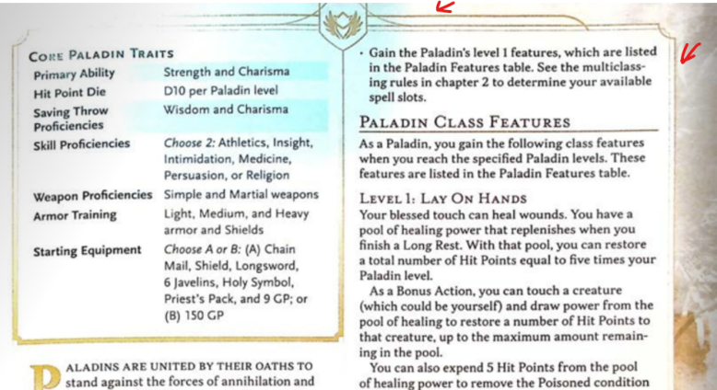
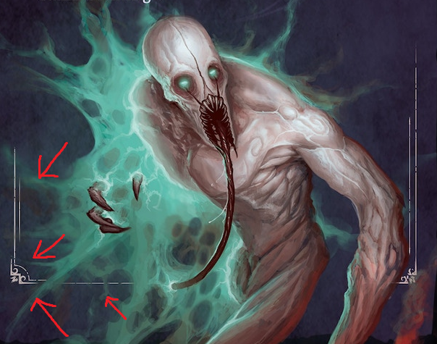
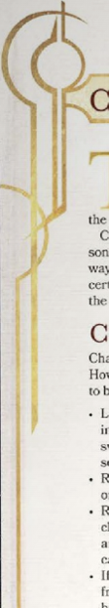
What I Need
- Borders with line art (like in the Welcome To Adventure image).
- The borders should be able to create squares or rectangles
- 2 to 3 different designs for different pages

Style & Specifications
- The style of the line art should be geometric, with straight lines. I attached several images with styles in the folder.
- The 2 main colors are rgb(146, 95, 168) #925fa8 and rgb(78 39 104) #4e2768. However, if you think a different color fits better on white background (like gold), that is good too!
- High resolution

The borders can be just PNG images.

Small Warning
I am not sure if I want to keep the background of pages like it is here (the zig-zag lines in the background).
If you can make it work with the zig-zag lines, that’s perfect! If not, you can just work with a white background.
The zig-zag background is attached in the folder.

3. Page Number Lines
I need some line art for the page numbers.

Guidelines
Each page of my book will have a number.
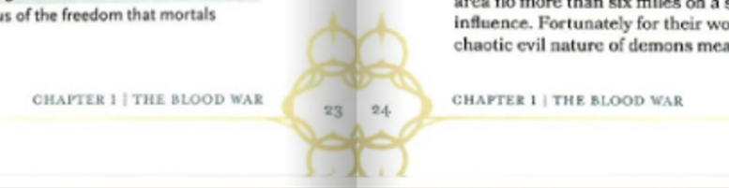
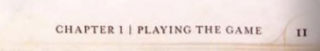
What I Need
- line art for the page numbering, symmetric
- 1 or 2 variants

Style & Specifications
- I prefer that the page number is in the middle. I feel it can be a better symmetric geometric design.
- If you decide to make them on the sides (like on the left here), please make sure the line art is not cropped like here!
- The style of the line art should be geometric, with straight lines. I attached several images with styles in the folder.
- The 2 main colors are rgb(146, 95, 168) #925fa8 and rgb(78 39 104) #4e2768. However, if you think a different color fits better on white background (like gold), that is good too!
- High resolution

Same as before with the zig-zag background. If you can make it work, great, if not, it’s also ok.

4. Card Borders Design
I need some line art design of some playing cards.

Guidelines
In my book, there are many card elements.
I need a better border for these cards.
Here are some examples of cards:
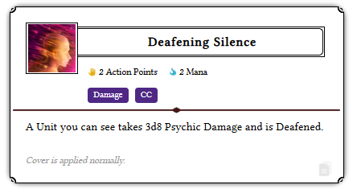
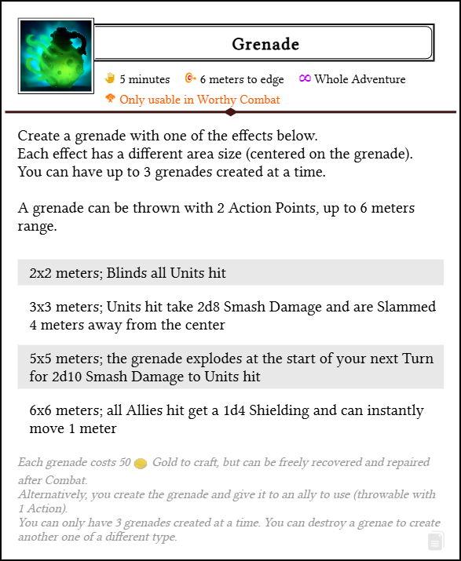

What I Need Line Art For
- Card borders
- Card name borders
- Icon borders
- Separator
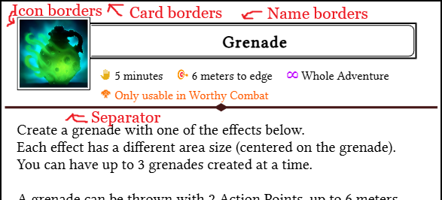

Do Not Change
- The font, the card layout, tables, sizes, etc. Please only change the borders.

Style & Specifications
- The card borders should be simple and narrow. The cards should fit the page well, without making them smaller.
- The name borders and icon borders should be very simple. Actually, maybe don’t even make an icon border if you don’t think it’s possible.
- The separator should be simple.
- All this line art should look similar to the other line art of the project.
- The style of the line art should be geometric, with straight lines. I attached several images with styles in the folder.
- You can make them black, or a different lighter color, like rgb(146, 95, 168) #925fa8 if you think it’s better.
- High resolution

NOTE: The cards can be different sizes!

5. Header Design
I need some design for the headers.

Guidelines
I have a lot of headers, but they are ugly.
We need to change these:
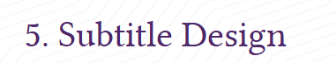
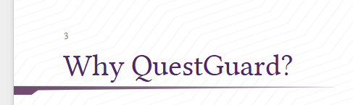
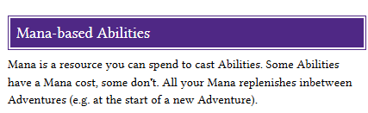

To something that looks better, like this:
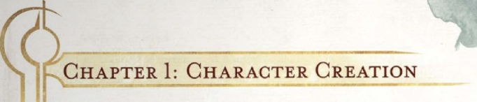
(even though I don’t like this one very much)
What I Need
- Line art for the page’s headers
- 2 variants

Style & Specifications
- It can have a background if you think that looks good
- The font for the subtitle can be any Serif font, but preferably Linux Libertine (attached in the folder). It can be uppercase or not, as long as it looks good.
- The style of the line art should be geometric, with straight lines.
- The 2 main colors are rgb(146, 95, 168) #925fa8 and rgb(78 39 104) #4e2768. If you can’t make it look good with these colors, feel free to try something else (preferably purple, black or gold).
- High resolution

6. Image Crop Mask
I need an image or border that I can use as a mask to crop some images.

Guidelines
If I have a normal image, I want to be able to apply a mask over it so that it crops the image to make it look more natural in the page.

Here is an example:
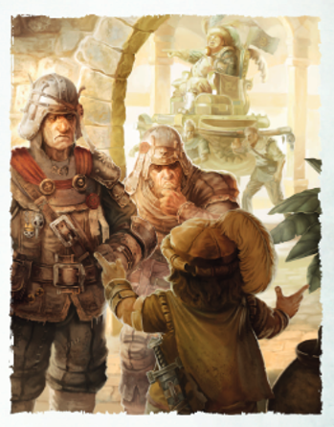
What I Need
- A border that I can use for the images, or black/white and transparent images that I can use as an eraser mask for the 4 edges of an image (left, top, right, bottom).

Style & Specifications
- The style of the mask can be geometric, if you can make it look good. Otherwise, it can just be something very similar to the image on the left, or to the attached examples.
- If you think you can add a geometric border, that would also be nice!
- High resolution

